

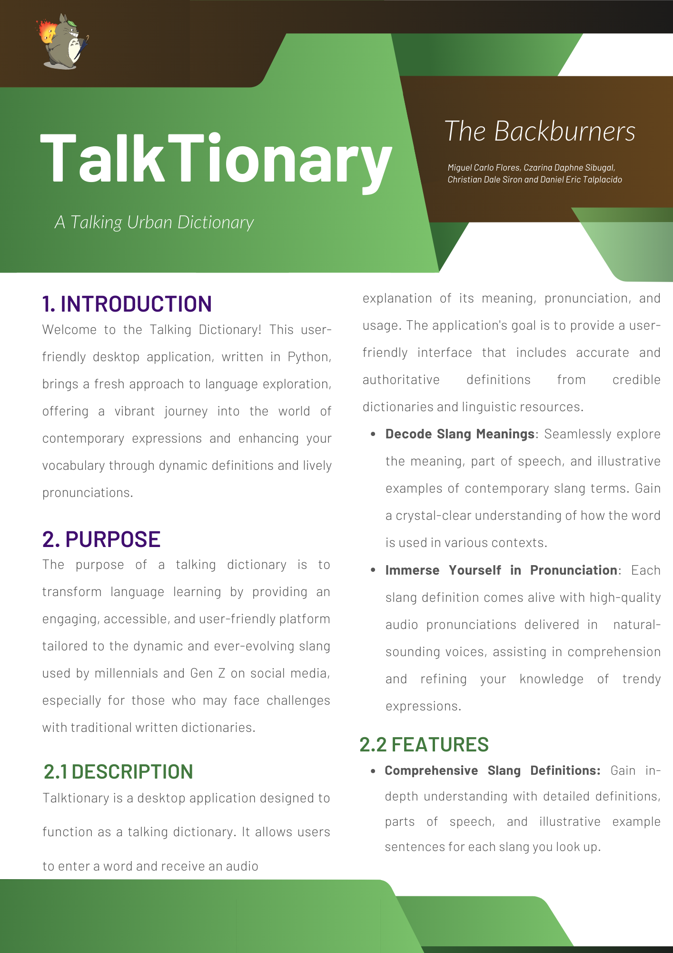

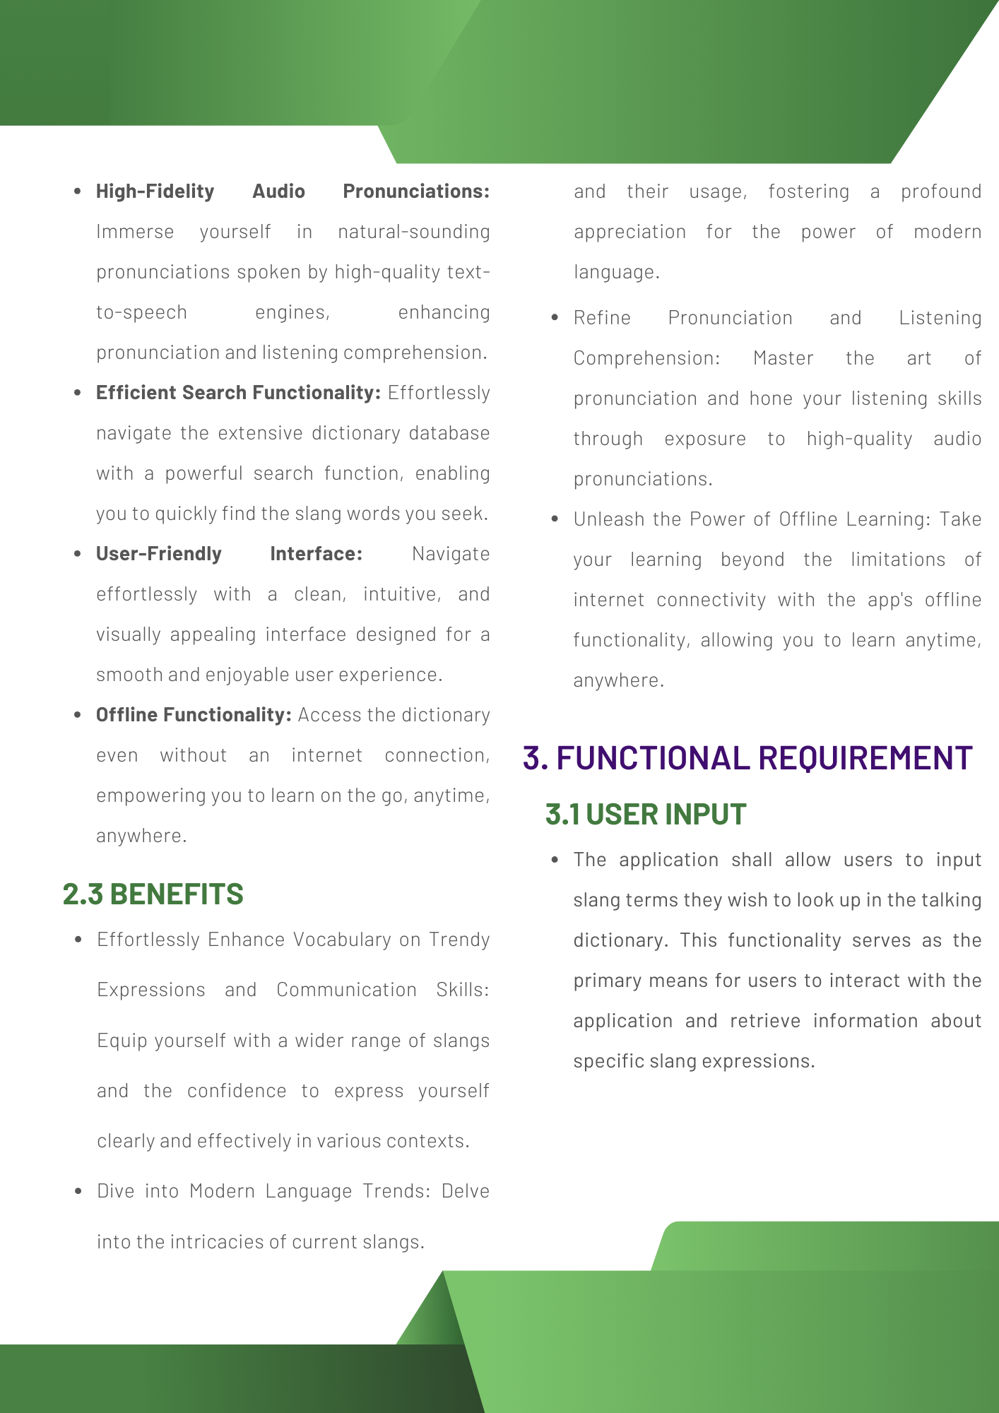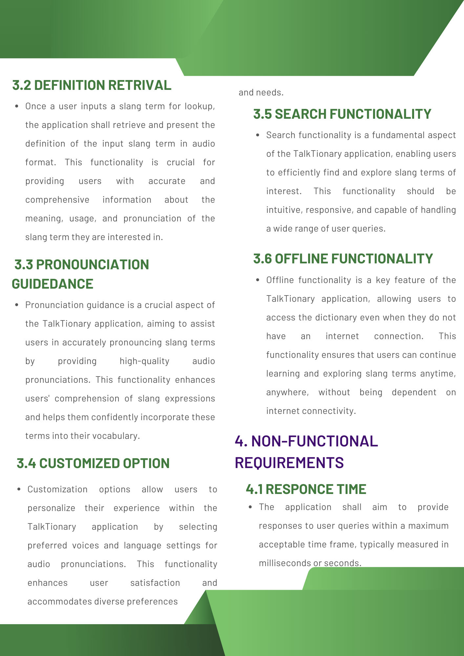

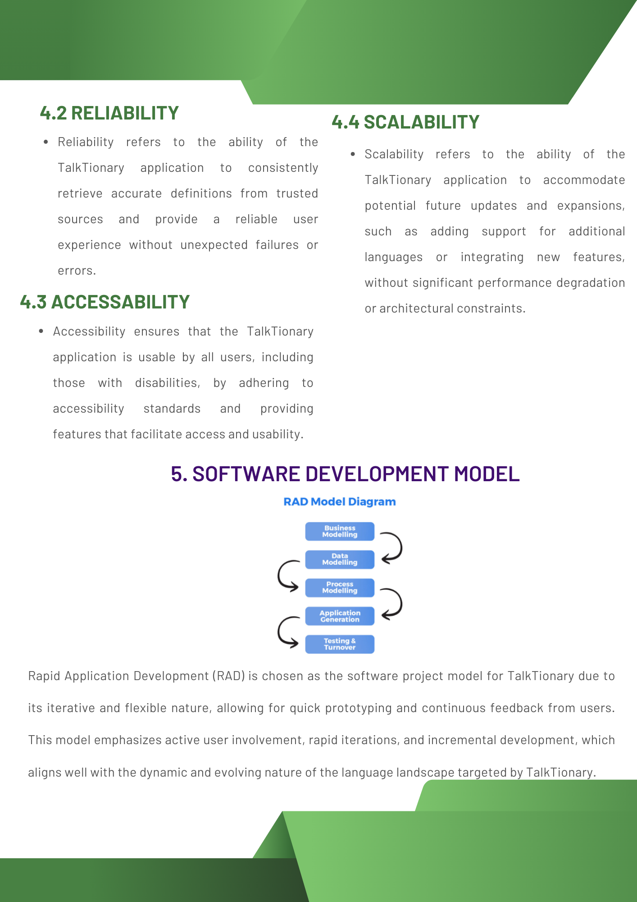

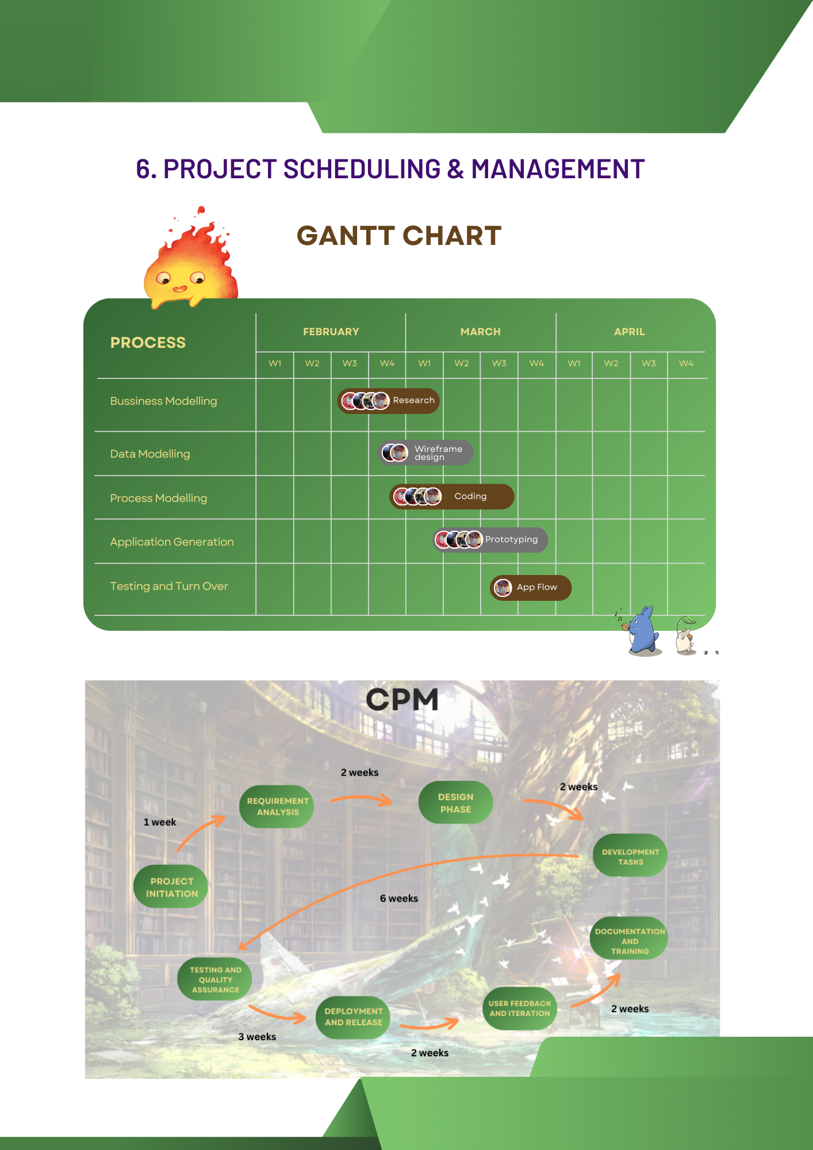

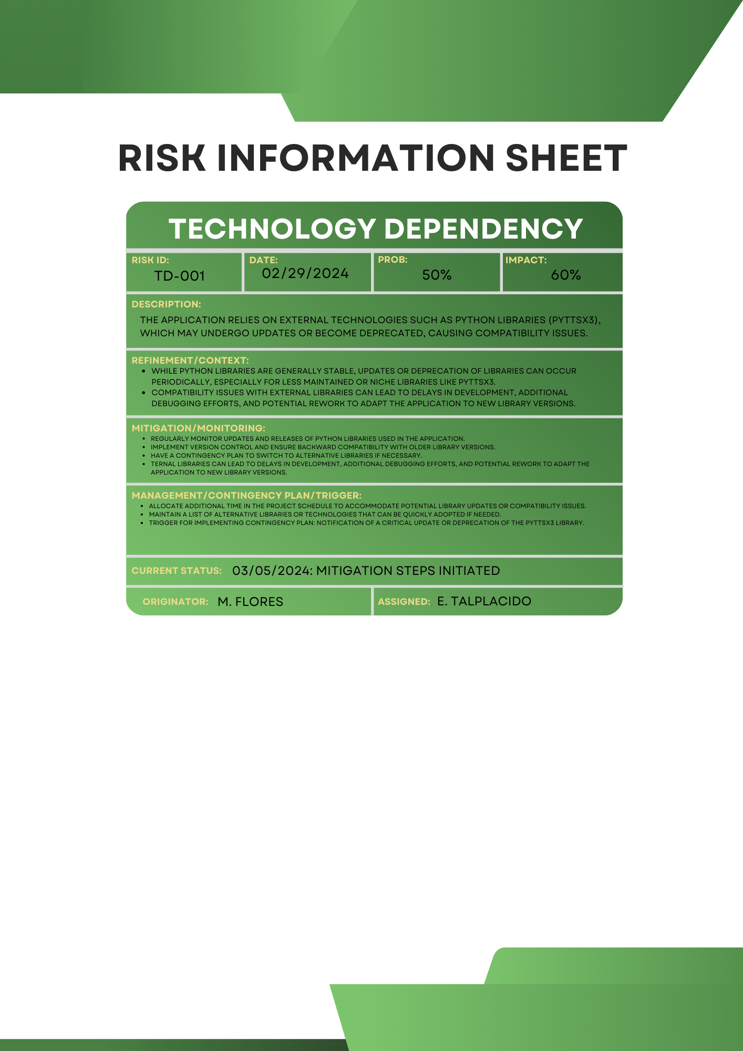

## 

## 

## Member Contribution:

Flores, Miguel Carlo:

Document Layout & Organization, App Idea. Description, Gantt Chart, UML

Sibugal, Czarina Daphne:

Intro, Purpose, CPM Chart, UCD

Siron, Christian Dale:

Benefits, Features, Software process model, DFD

Talplacido, Daniel Eric:

Functional & Non-Functional Requirements, Software process model

Gdrive link of Prototype Application: <https://drive.google.com/drive/folders/1HkABN-H2LBkqS-BZiQUADAcjGcMvTKLZ?usp=drive_link>